Culture and Education
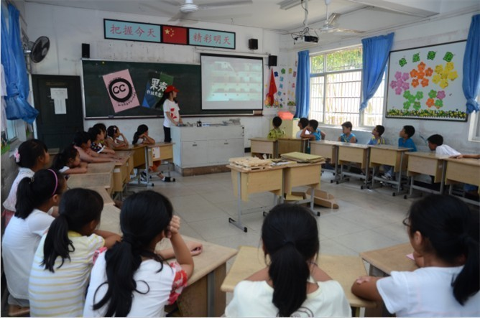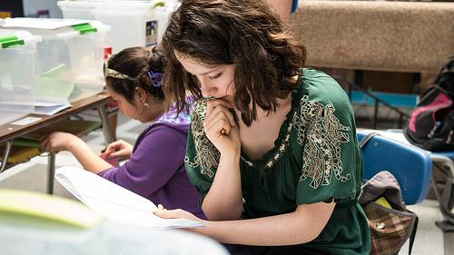

Definition of Socialization: The process by which we all come to believe that there is a “right” way to think, express ourselves, and act is called socialization. It is the process by which individuals learn what is required of them in order to be successful members of a given group, what is right and good. Socialization looks at the future and the past. It looks forward to where people are expected to be and backward to decide what behaviors, values, and beliefs are important to continue.

If people are unaware that other ways of thinking, living, and acting exist, they tend to judge others from only their own culture’s perspective. Someone is ethnocentric if they believe their own beliefs to be the only “right” or “correct” way to perceive the world. In contrast, ethnorelativism is understanding that our own beliefs and behaviors come from how we are socialized, and are just one way to live and see the world among many other possibilities. (Intercultural Interactions: A Practical Guide. P. 5)

Activity 1. The following activity will focus us on thinking about how we have been socialized to view educational practices. This will help when you are in a culturally different classroom environment. Check all the boxes that apply to your first culture:
In your country, it is generally expected, common and acceptable that teachers...
- call on students to participate in class by asking and answering questions.
- organize students to work in groups.
- meet with students after class during office hours and in an office.
- meet with students after class anytime and anyplace.
- provide verbal feedback or correction to students in front of other students in class.
- maintain eye contact with students.
- admit when they are unsure of the answer.
- physically discipline students.
- assign homework.
- tell students to put away their phones while in class.

In your country, it is generally expected, common and acceptable that students…
- participate in class by asking and answering questions.
- participate in out of class extracurricular activities (e.g. sports, music, etc.).
- call a teacher by their first name.
- respectfully debate or disagree with other students and perhaps even the teacher.
- participate in group work with opposite gender.
- ask permission to enter or leave a class.
- voice complaints, first to the teacher of the class.
- voice complaints, first to the director/principal of the school.
- maintain eye contact with teachers to show that you are confident and engaged.
- make an educated guess, even if you are not 100% sure of the answer.
- get help with a take-home exam, or copy someone’s work.

Compare your answers. What do the differences and similarities tell you about the cultural expectations of the classroom? What are the underlying reasons for these behaviors? Why!?!

Classroom Culture and Behavior

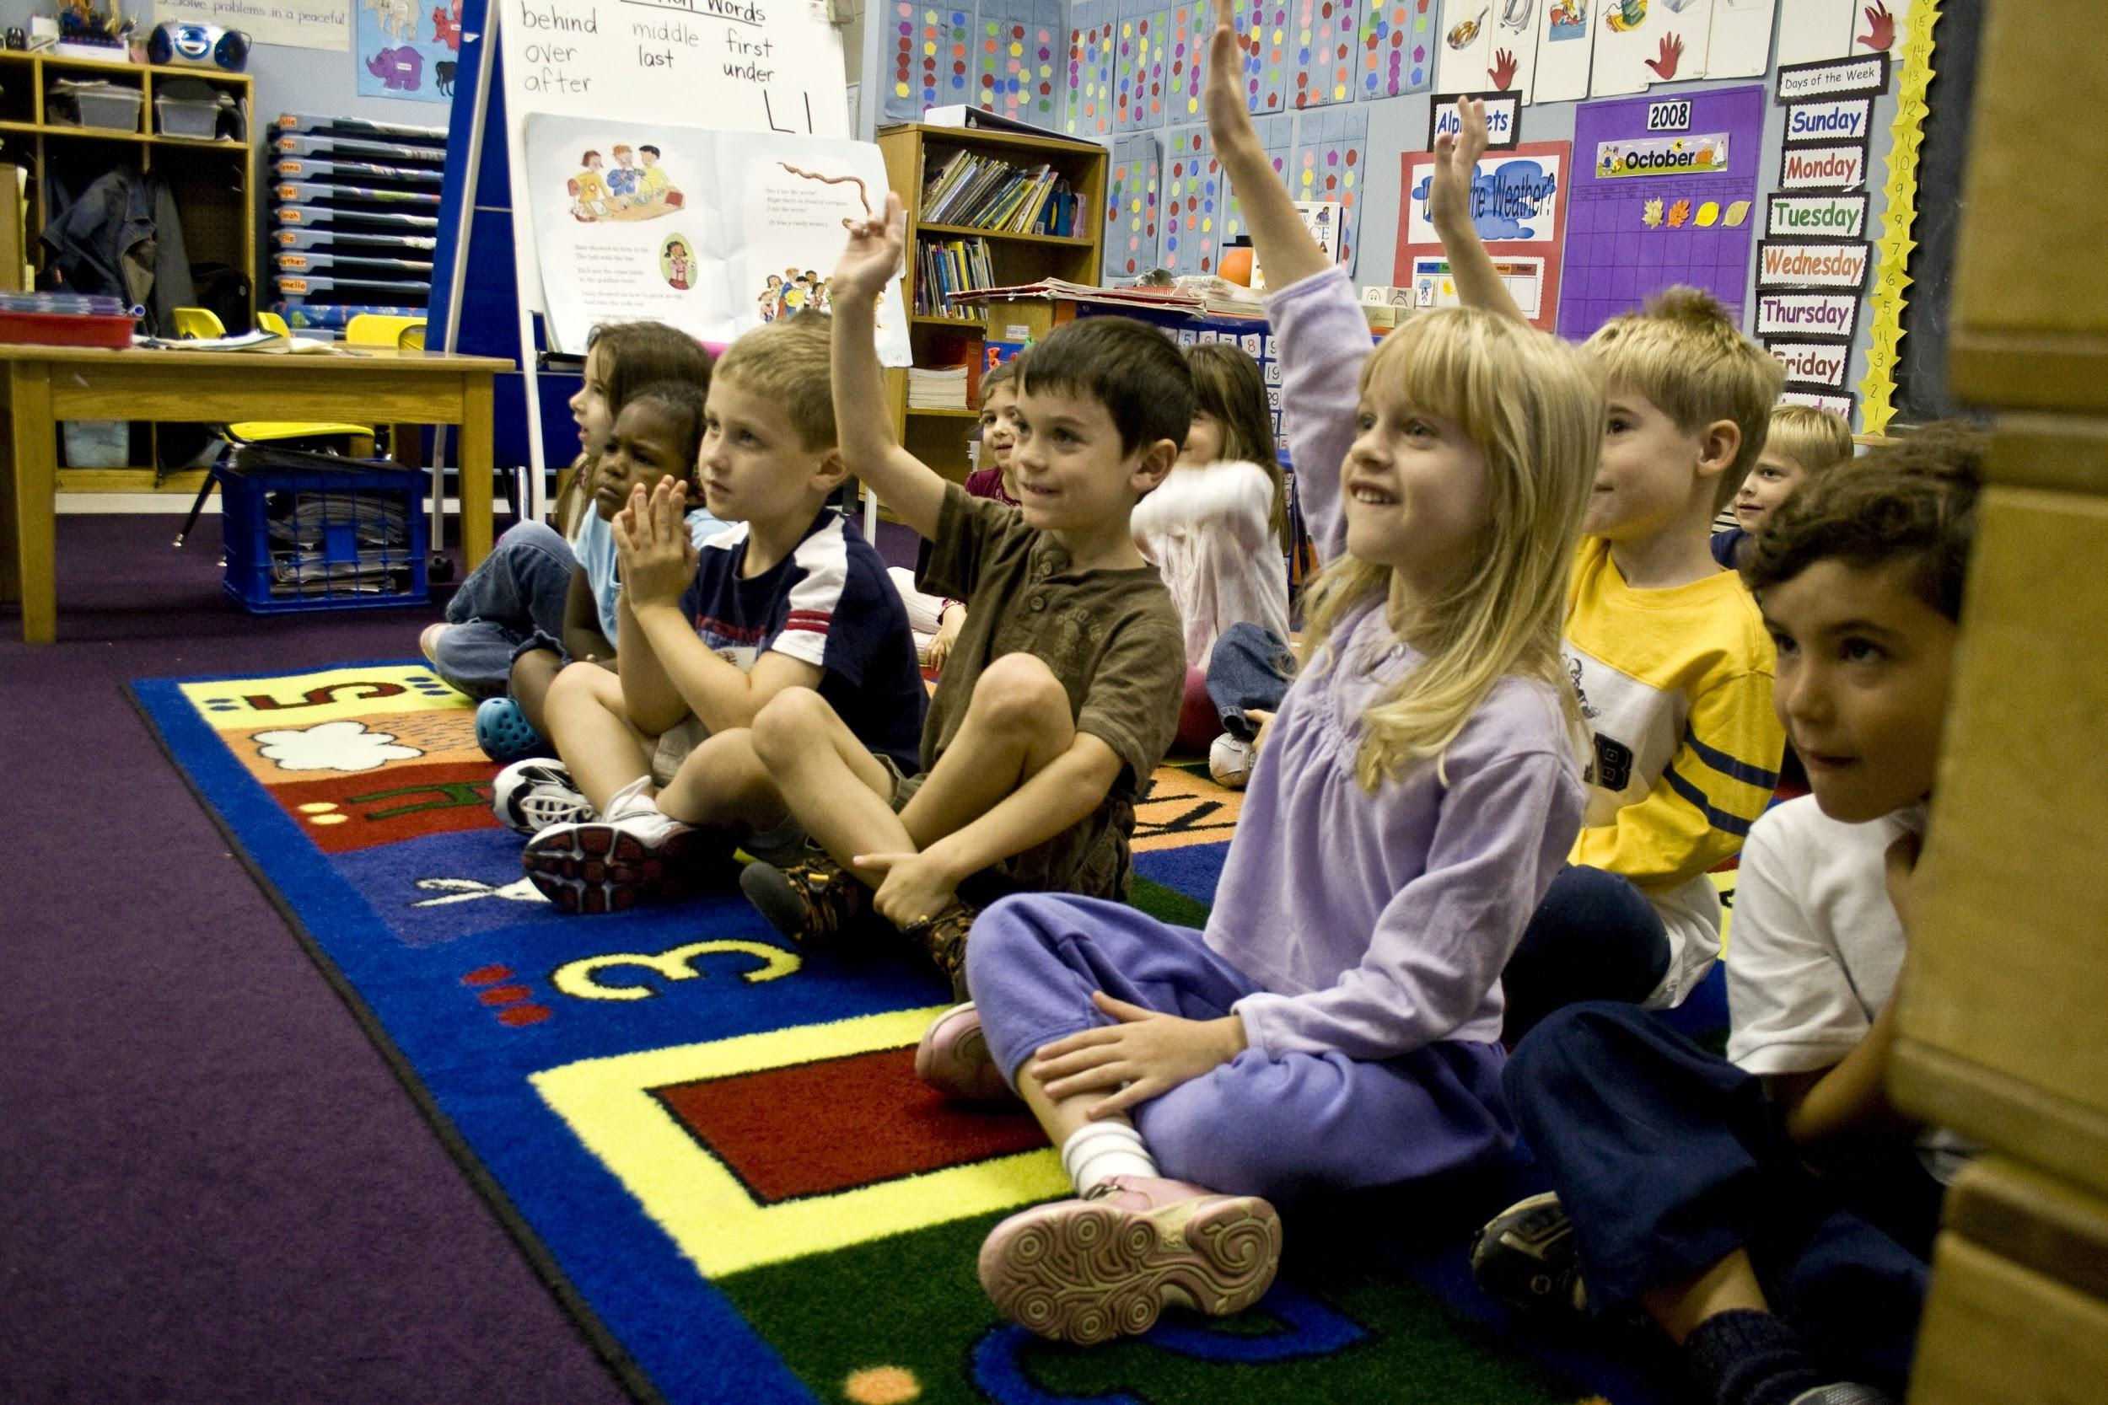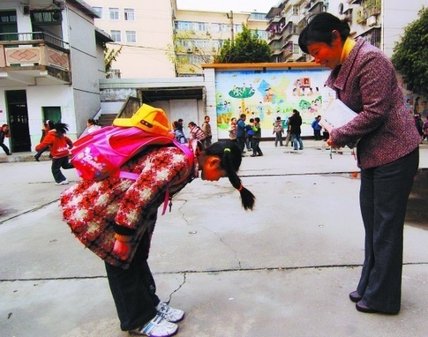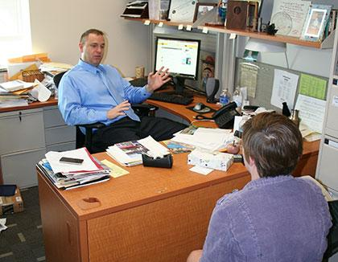

Activity: Help each other understand what is required to be a successful student in the country you are from. Discuss and demonstrate the “appropriate” or “expected” behavior (verbal and nonverbal) in the following situations from your first-culture point of view. They may be different! Use your experience in CIES and the U.S. to compare school behavior. Discuss what are the reasons for these behaviors in your first culture and in the U.S. Why is it important to behave in this way?
- How to show you are paying attention in class (e.g. eye contact, nodding head, verbal feedback).

- How close people should stand/sit next to each other while talking. Consider the following: gender (male/female), age (older/younger), relationship (friend, teacher, etc.).

- How to volunteer to ask a question in class (e.g. raise hand, snap, wait until the teacher calls on you, etc.).

- How to interact with a teacher (e.g. bow, stand when he/she comes in the room, gift giving).

- Anything else that you think is important and different:

