The Florida State University Graduate School Presents:
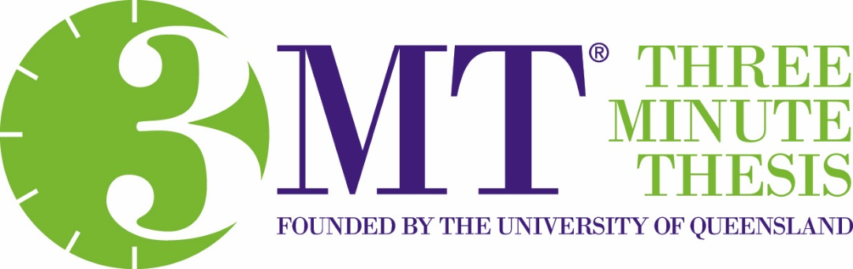
Doctoral student finalists will describe their research in just three minutes!
November 27th at 6:00 p.m.
Durell Peaden Auditorium, College of Medicine
Please attend in support of
Anwer Al-Kaimakchi- Civil & Environmental Engineering
Sylvia Bhattacharya – Electrical & Computer Engineering
Diana Carbonell – Educational Psychology & Learning Systems
Bruno Chiurliza – Psychology
Gokila Dorai – Computer Science
Alyssa Henderson – Physics
Eve Humphrey – Biological Sciences
Simeng Li – Civil & Environmental Engineering
Tianhan Liu - Physics
Carla Parades – Educational Leadership & Policy Studies
Hamidreza Rahmani – Molecular Biophysics
Rebecca Turk – Teacher Education
Pengpeng Wang – Statistics
Sarah Wood - Psychology

Each finalist will receive $100.
First Place ($1,000) and Second Place ($750) winners will be selected by a panel of judges.
Audience members will vote for the People’s Choice Award ($500)!

